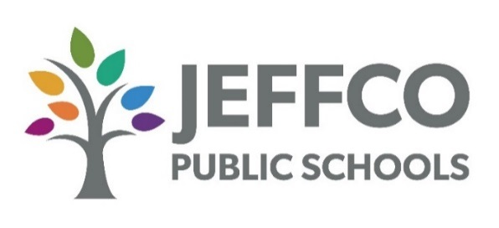
Notice
Concerning Prequalification
for Consultants
and Professional Service Providers

Jefferson County School District R-1 is soliciting applications from consultants and professional service providers for inclusion in the District’s prequalified professional services provider list (the “Consultant Pre-Qual List”).
The Consultant Pre-Qual List serves as the District’s primary directory of pre-qualified professional services firms for soliciting project bids. The District frequently issues invitations to bid and requests for proposals in the following consultant and professional service categories:
Architects
Engineers
Planning and Design Professionals
Landscape Architect
Consultant in Specialty Fields (indicate on application)

Professional service firms providing services in the above and related categories are invited to complete the attached “Request for Qualification Form.” The District determines which applicants meet the District’s requirements of a construction consultant or professional services provider in the applied for field. Those who meet the requirements will be added to the Consultant Pre-Qual List. The District accepts bids and proposals only from companies on that list.

